Driven Racing Oil™ Injector Defender Gasoline Fuel Additive
Huntersville, NC – A new additive from Driven Racing Oil™ is formulated to ensure clean and proper-functioning fuel injectors common in today’s engines.
Driven Injector Defender Gasoline prevents harmful corrosion due to today’s Ethanol-blended and poor-quality gasoline. Not only does Injector Defender restore performance and protect fuel injection systems from performance-robbing deposits, it also provides fuel stabilization and preservation. This additive provides a pour-in solution that will not harm sensors in all fuel-injected cars, trucks, motorcycles and marine engines. Each 10-ounce bottle treats up to 25 gallons of gasoline.
Part Number: #70048 (10 oz. bottle); Price: $9.99
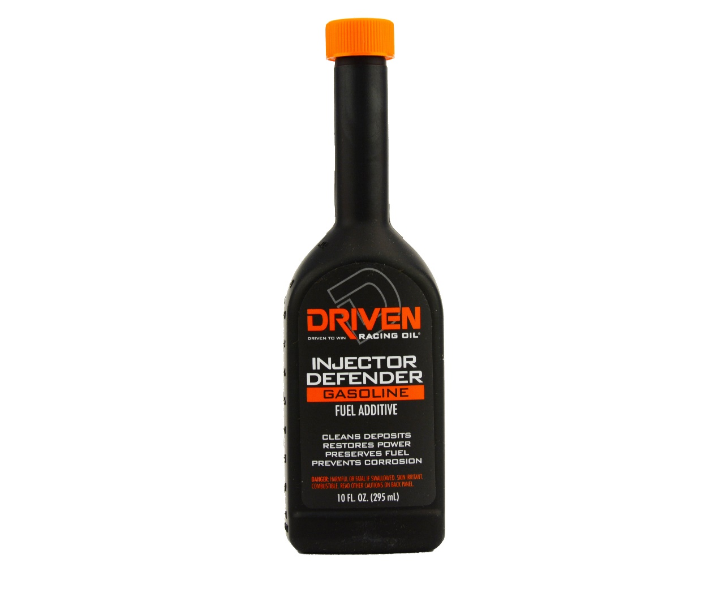

About Driven Racing Oil™
Born from Joe Gibbs Racing, one of the most successful NASCAR teams of the past two decades, Driven Racing Oil™ utilizes cutting-edge lubricant technology and on-track research for maximum performance gains from all of its product offerings. Competition drives innovation, and Joe Gibbs Racing originally developed the Driven brand of oils to advance engine and driveline performance on the racetrack. From full-synthetic race oils to engine break-in oils and cleaners, Driven offers a wide range of race and street products that deliver performance, protection and value.

